**Task 1 - Interact with an SMTP server**

**Q. Capture the successful SMTP exchange in your terminal session and submit as a text document**

Last login: Fri Sep 10 11:45:55 2021 from 149.160.252.53

abkuma@silo:~$ telnet mail-relay.iu.edu 25

Trying 129.79.1.38...

Connected to mail-relay.iu.edu.

Escape character is '^]'.

220 Sendmail ESMTP - IU Campus Communications Team - Mail-Relay

HELO google.com

250 mail-relay.iu.edu Hello silo.luddy.indiana.edu [129.79.247.195], pleased to meet you

MAIL FROM : abkuma@iu.edu

250 2.1.0 abkuma@iu.edu... Sender ok

RCPT TO : sice-networks-l@list.indiana.edu

250 2.1.5 sice-networks-l@list.indiana.edu... Recipient ok

DATA

354 Enter mail, end with "." on a line by itself

Subject : "Abhinav Kumar Assignment 01 SMTP"

.

250 2.0.0 18AFoi4U001201 Message accepted for delivery

QUIT

221 2.0.0 mail-relay.iu.edu closing connection

Connection closed by foreign host.

abkuma@silo:~$

**Q. What happens when you try to send to a non-IU email address? Why?**

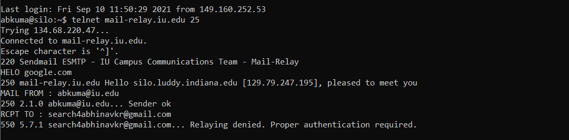

If we are trying to send an email to non-IU email, then mail server will deny from sending the email. It is because IU email server restrict the sender which are not in their domain for the safety purpose.

**Q. What happens when you use a made-up from address? Why?**

The mail server is not authenticating from address and only validating the to address so email can be send from the made-up email.